CREATING A SOCIAL MEDIA

INTRODUCATION

  - Overview

- Do a social media audit.
- Set up accounts and improve profiles.
- Fing inspiration.
- Create a social media content calendar.
- Get to know your competition.
1.2Purpose
      - Make a plan for customer service.
      - Develop a recipecard to guide you.
      - Measure your results.
      - Incorporate ecommerce.
      - Focus on a few key channels.

2.Problem definition & Design Thinking
2.1 Empathy map
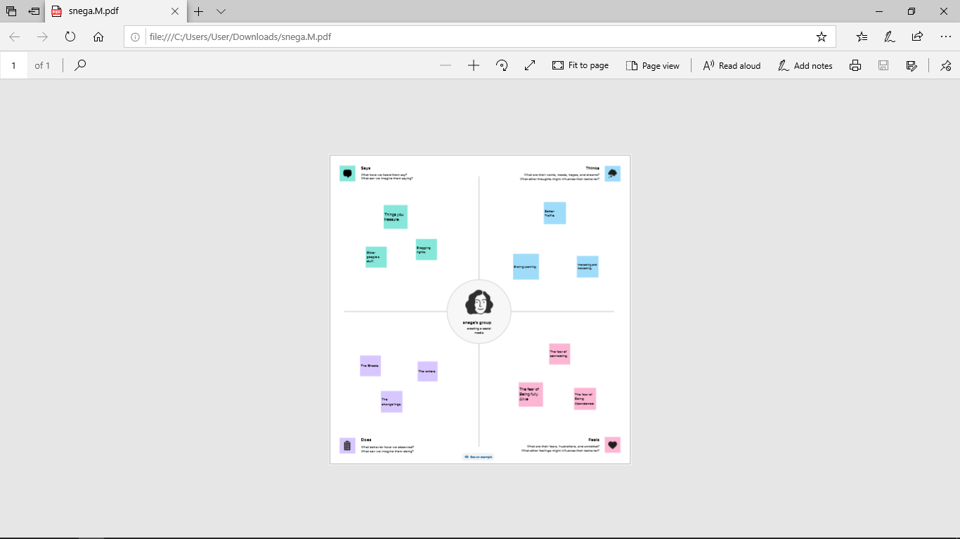

2.2 Brainstorming 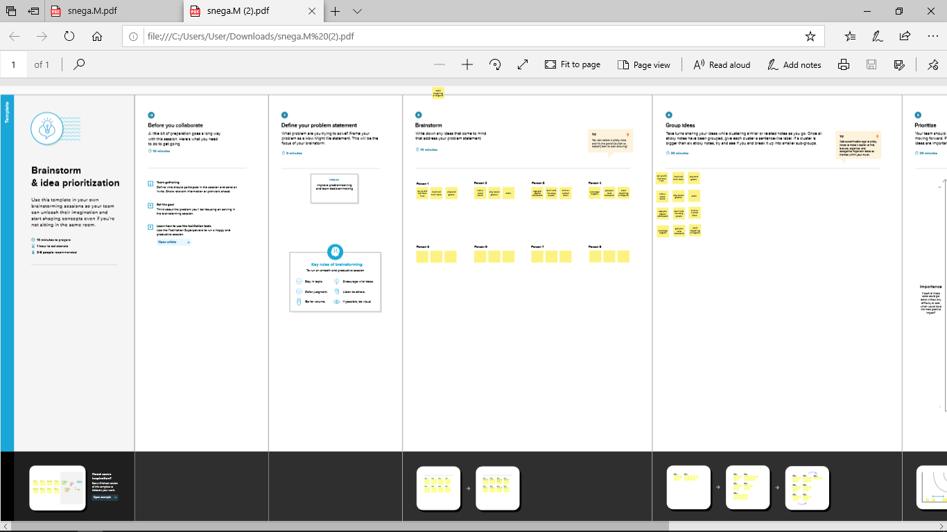

Result:

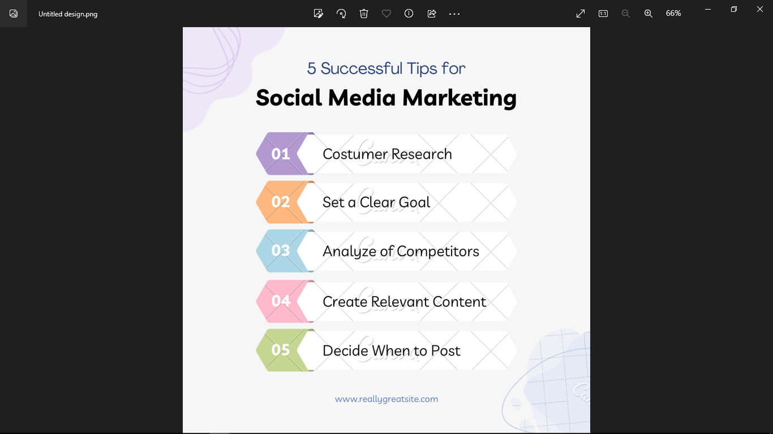

- ADVANTAGES AND DISADVANTAGES
ADVANTAGES
- Economies of scale_lower average costs from increased scale
- High profit can be used for research and development_dynamic efficiency
- The reward of getting patent (a monopoly power)can encourage investment
- Firms who become monopolies may just be very efficient,successful and innovative.
- Governments can regulate to get best of both worlds_economies of scale and fair prices.

DISADVANTAGES
  - Higher prices for consumers
  - Less incentive to cut costs
  - Less inventive to innovate and invest
  - Allocative inefficiency
  - Lesschoice for consumers
  - Productive inefficiency

APPLICATION:
Social media is a collective term for websites and applications that focus on communication,community-sharing and collaboration.People use social media to stay in touch and internet with friends,family and various communications.

CONCLUSION;
In conclusion,social media has plenty of good uses as it allows stories or events that began locally to gain a global or worldwide attention.

